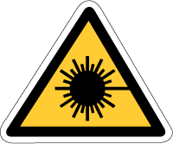
Lasers
The laser has become part of our lives and will be used much more in the years to come so we will start this section with a look at a few of the purposes for which lasers are used:
repairing damaged retinas
bar code reader
communication via modulated laser light in optical fibres
neurosurgery - cutting and sealing nerves sterilization – key hole surgery (microsurgery)
laser video and audio discs (CD and DVD)
cutting metal and cloth
laser pointer
laser printer
holography - three-dimensional images
surveying - checking ground levels
production of very high temperatures in fusion reactors
laser light shows
laser guidance systems for weapons
making holes in the teats of babies' bottles
laser defence systems ('Star Wars')
cutting microelectronic circuits
physiotherapy - using laser energy to raise the temperature of localised areas of tissue removing tonsure tumors
laser lances for unblocking heart valves removal of tattoos or birth marks
a modification of the Michelson-Morley experiment to check the existence of the ether
distance measurement
laser altimeters

Theory and development of the laser
We will now look at the development and some simple theory behind the operation of the laser.
A radio transmitter can emit a beam of electro- magnetic radiation that is far purer than that emitted by a light source - in other words, much more energy is generated with a small spread of frequency. It would be good to be able to generate electromagnetic waves in the visible region so precisely and this did in fact become possible in the 1960s with the invention of the optical maser or laser, the name deriving from light amplification by the stimulated emission of radiation.
Atoms in hot gases are continuously being raised to higher energy states and their electrons then fall back at random, so giving a disorderly outpouring of quanta. This is also true of the electrons in a hot tungsten filament lamp. Conventional light sources are therefore incoherent sources, since we have no control over when an atom is going to lose energy in the form of radiation. The light that comes from a laser, however, is coherent, parallel, monochromatic and in unbroken wave chains.
We can make a normal light source more coherent by making it smaller, so reducing the number of atoms that may emit quanta, but if we do this the intensity is reduced. The total energy radiated by the Sun is about 7 kW per square centimetre of surface, and although this may sound a large amount it must be remembered that this energy is spread out over a very large range of frequency across the solar spectrum. If we try and filter out a narrow band of light 1 MHz wide in the region of the Sun's greatest (about 480 nm) then we find that 1 cm² of surface will give an output of only 0.000 01 W! So to get 1W we would need to concentrate the light from 10 square metres of solar surface and of course using this large area would completely destroy the coherence of the source.
The width of a standard television channel is about 4 MHz but the visible region of the solar spectrum alone has a width of some 320 million MHz, and could therefore contain about 80 million television channels! Modern transmitters will emit up to 250 kW in the television region, however, in a band less than 1 MHz wide. The search therefore began for powerful coherent light sources.
The first attempt was made by generating electromagnetic waves by electronic means, but even with a microwave resonator the shortest wavelength possible was about 1 mm (1 000 000 nm).
Researchers then had the idea of using atoms and molecules as the resonant structures, but unfortunately the power available from just one electron transition is very small and it only occurs intermittently. They therefore had to try and persuade all the atoms in a specimen to react simultaneously since this would produce a powerful coherent wave. This was made possible using the maser principle discovered by Charles Townes at Columbia University in 1954
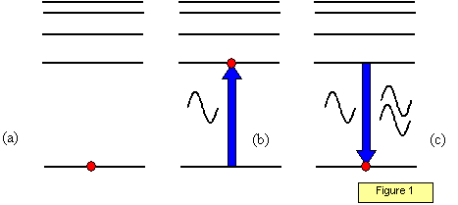
The basis of the maser is that of stimulated emission and is shown in Figure 1. Figure 1(a) shows an electron in its ground state (E_{o}); in Figure 1(b) a photon with just the right energy raises the electron to an excited state E₁, and in Figure 1(c) another photon reacts with the atom causing the electron to fall back to level E_{o}. The photon produced adds its energy to that of the stimulating photon.
If this process goes on through the body of a specimen a beam of radiation will be produced which is perfectly coherent and parallel.
For the lasing action to work the electrons must stay in the excited (metastable) state for a reasonable length of time. If they 'fell' to lower levels too soon there would not be time for the stimulating photon to cause stimulated emission to take place.
The first successful optical maser (or laser) was constructed by Maiman in 1960 using a small ruby rod; ruby is a form of aluminium oxide in which a few of the aluminium atoms have been replaced by chromium.
Light is absorbed from a flash tube wrapped round the rod and this raises the electrons up to an excited level E₃. They fall back rapidly to the metastable level E₂, after which further light will stimulate laser action back to level E_{o} (Figure 2(a)). The light emitted is red with a wavelength of 693.2 nm. One end of the rod is silvered and the other end half silvered so that the beam reflects backwards and forwards along the rod, and a pulse of light is emitted from one end.
The original laser used a ruby rod 4 cm long and 0.5 cm in diameter, producing an intense red beam for 0.0005 s. Figure 2(b) is a diagram of the structure of the laser and Figure 2(c) illustrates the idea of stimulated emission: one photon moving parallel with the axis of the tube stimulates a second atom to emit a photon, these stimulate further atoms to emit and so on. The result is an intense beam of laser light moving parallel to the axis of the rod.
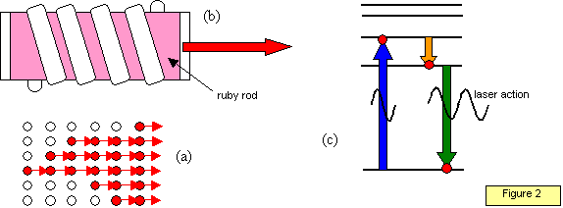
The ruby laser gives up to 10 kW in a beam less than 1 cm in cross-sectional area, and with other lasers even greater powers have been produced. The carbon dioxide laser, for instance, will give 1 kJ of energy in 1 ns, producing a power of 10¹² W, or one million megawatts.

Coherent and non-coherent light
Coherent light is light in which the photons are all in 'step' – other words the change of phase within the beam occurs for all the photons at the same time. There are no abrupt phase changes within the beam. Light produced by lasers is both coherent and monochromatic (of one 'colour').
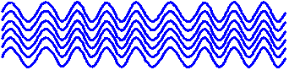
Incoherent sources emit light with frequent and random changes of phase between the photons. (Tungsten filament lamps and 'ordinary' fluorescent tubes emit incoherent light)
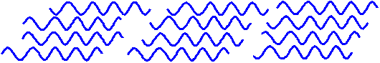

Power density
The laser beam also shows very little divergence and so the power density (power per unit area) is very high.
For example consider a 100 W light bulb. At a distance of 2m the power density is 100/4πr² = 2 Wm⁻².
The beam from a helium-neon gas laser diverges very little. The beam is about 2 mm in diameter 'close' to the laser spreading out to a diameter of about 1.6 km when shone from the Earth onto the Moon!
Therefore at a distance of 2m from a 1 mW laser the power density in the beam would be 4π/0.001 = 1.25x10⁴ Wm⁻²!

Types of lasers
Semiconductor lasers
These lasers, sometimes called diode lasers, are generally very small and use low power. These are used to 'read' the disc in CD and DVD players
Gas lasers
These lasers use a gas as the lasing medium. The most common being helium and helium-neon emitting visible red light. CO₂ lasers emit energy in the far-infrared.
Solid-state lasers
These operate with a solid lasing material such as the ruby or neodymium-yttrium-aluminium garnet "Yag" lasers). The neodymium-Yag laser emits infrared light at 1,064 nm
Dye lasers
These use complex organic dyes, such as rhodamine 6G, in liquid solution or suspension as lasing media. The big advantage of this type is that they can be tuned.
Wavelengths of some common lasing materials
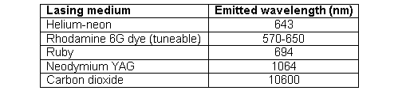

The laser disc
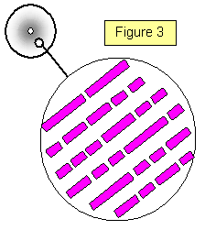
One of the important uses of laser technology is in the development of the laser disc system. Since the amount of information that may be carried on a laser disc is enormous: one video disc can carry as much information as a whole set of the Encyclopaedia Britannica.
The original laser discs were superficially similar to a record, in that it was a 30 cm diameter disc with a spiral track running round it; there the similarity ends, however.
On the laser disc the track is only about 1 μm wide and is made of a series of tiny pits, each pit some 0.16 μm deep and of varying length (Figure 3). These pits are scanned by a fine laser beam only 0.9 μm in diameter. The reflected light from the flat part of the disc is detected by a photodiode and this modulated beam is converted into a television picture. The disc is given a thin metallised coating and is then protected by a layer of plastic through which the laser light can pass.
With a constant angular velocity (CAV) disc about 54 000 television frames may be carried, with some 28 x 109 bits of information per side!

The CD and the DVD
The compact disc has now been developed and is widely used and the advent of the DVD (Digital Video Disc) with finer tracks enables even more information to be stored on small discs. For example a CD will hold up to 750 Mb of information, at present the 5250 pages of the schoolphysicsphysics site occupies a mere 157 Mb!

